|  |  |
| --- | --- |
| **DOKUMENTASI EKSTERNAL**  External Documentation |  |
| **[~~TUGAS MANDIRI~~ / PROYEK ]**  **[*~~Assignment~~ / Project*]** |
| **MATAKULIAH <XX999> – HUMAN AND COMPUTER INTERACTION**  ***Subject*** |
| SEMESTER [~~GANJIL~~/GENAP/~~PENDEK~~] 2019/2020 ***[~~Odd~~/Even/~~Compact~~] Semester Year 2019/2020*** |

## Judul Proyek

*[Assignment / Project]**Title*

* **Rainbow Seven Siege Website**

## Abstrak [50 – 200 words]

*Abstract*

* **Give information about the application features such as the quality of calls, share computer screen, call a mobile number, application promotional video, and etc. Also provides hyperlink for user to download the app.**

## Pendahuluan

*Introduction*

* **INTRODUCTION**

## Dokumentasi

*Report / Documentation*

* **REPORT / PRINT SCREEN & DESCRIPTION**
  + **HomePage [Desktop View]**

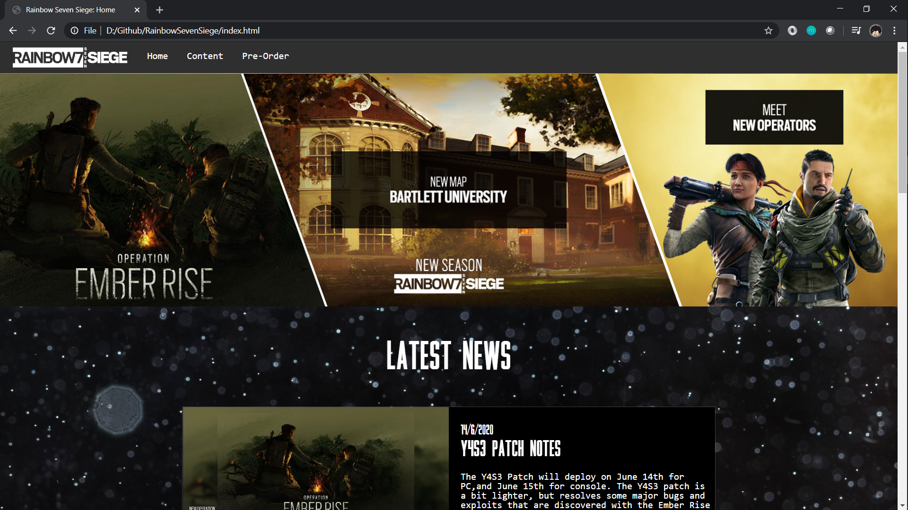

* + **Operators Page [Desktop View]**

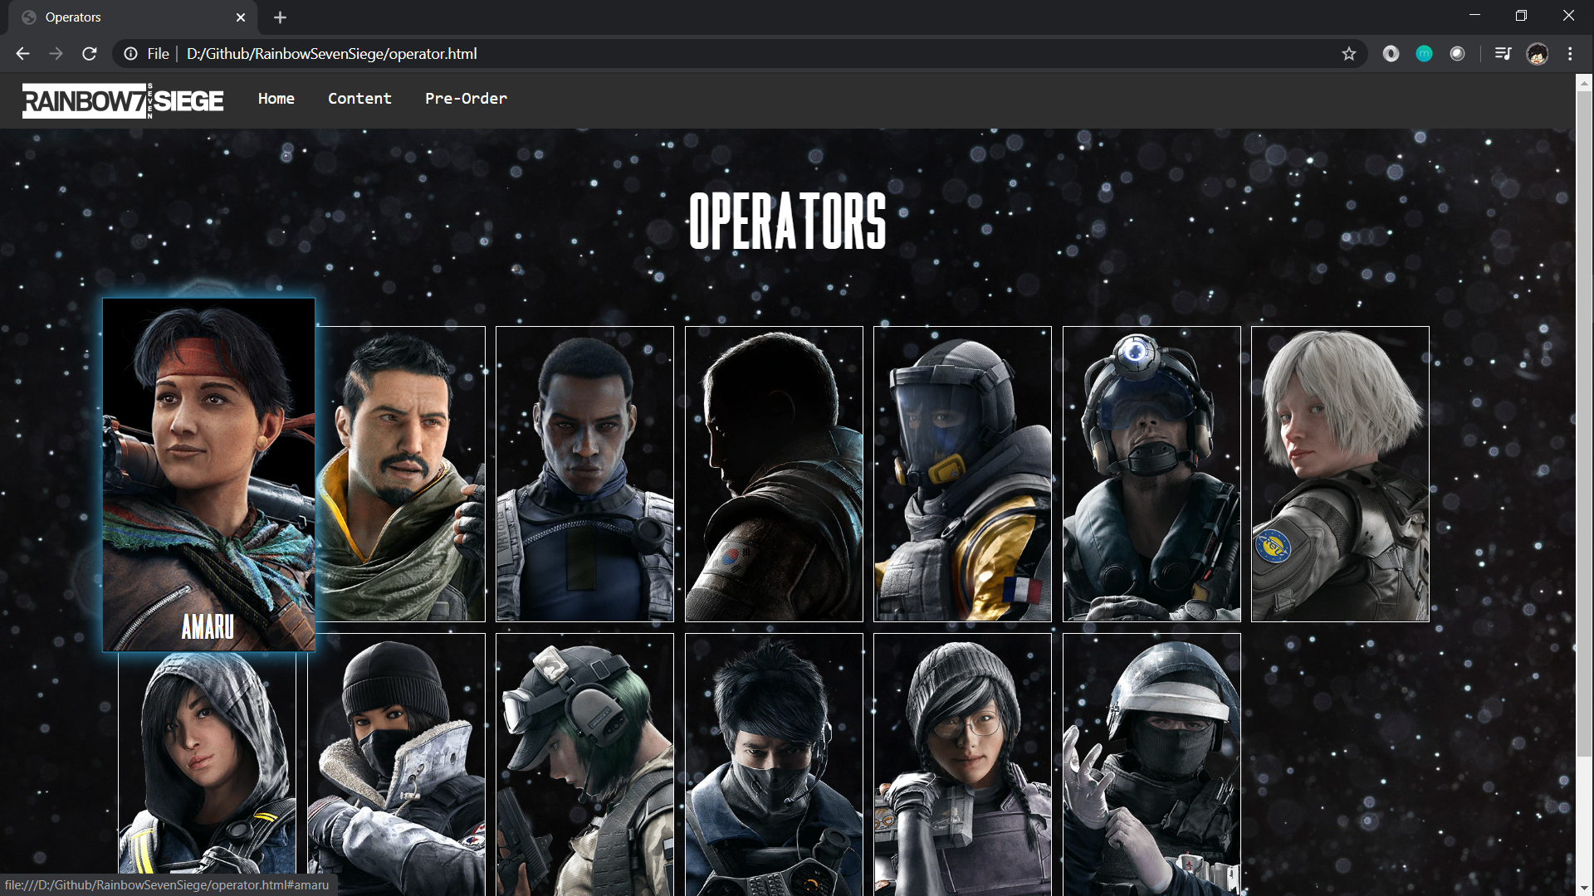

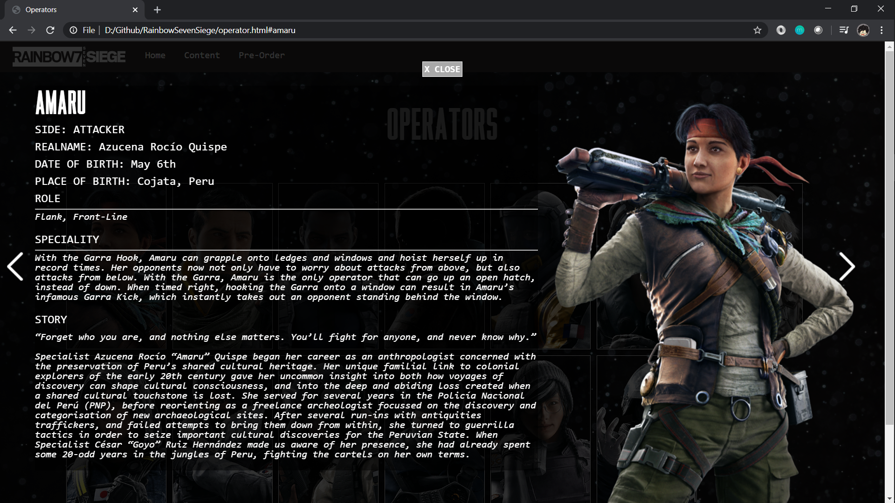

* + **Maps Page [Desktop View]**

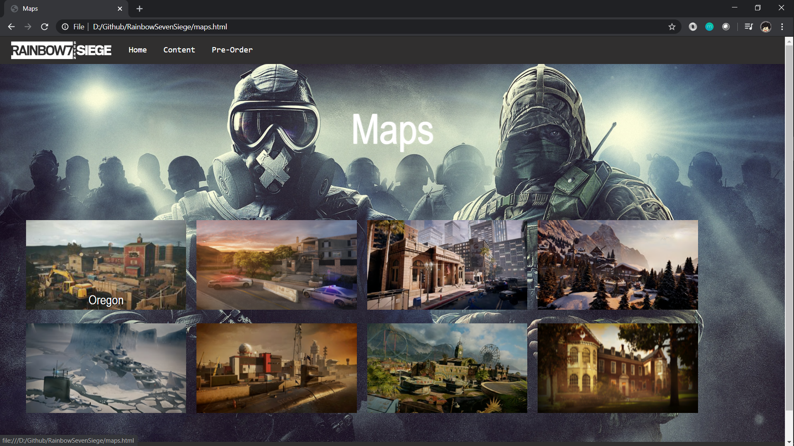

* + **Quarantine Page [Desktop View]**

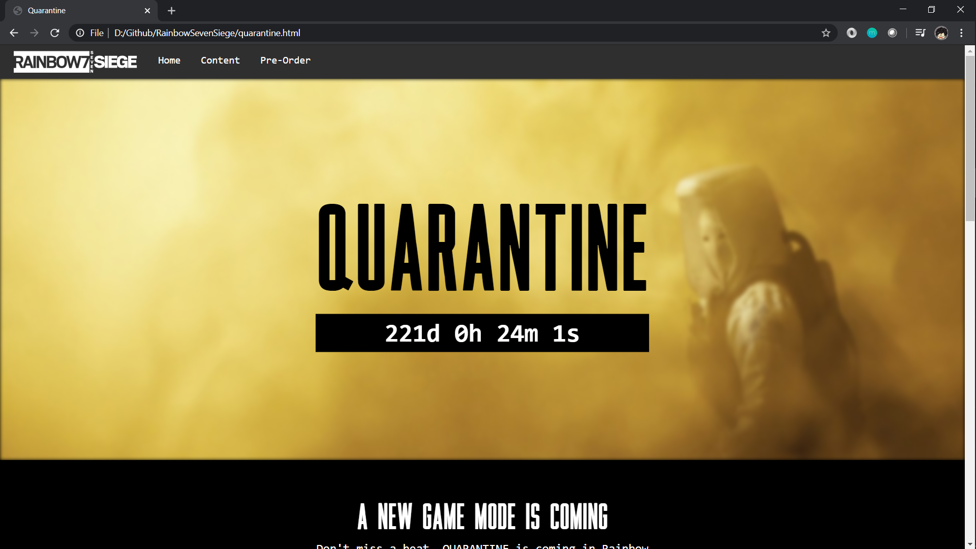

* + **Pre-Ordere Page [Desktop View]**

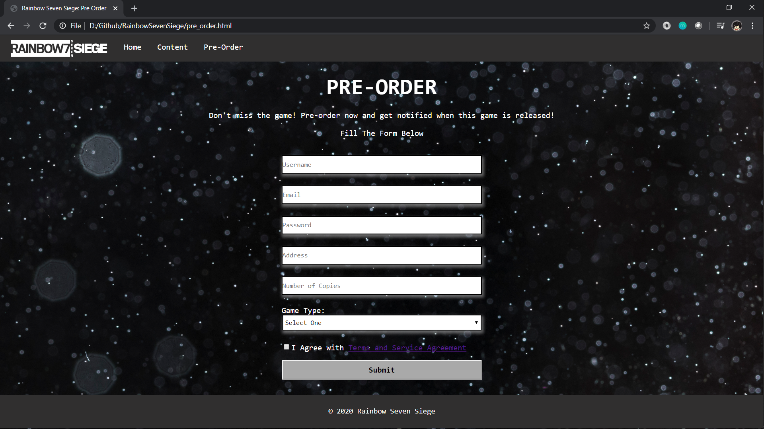

## Referensi

*References*

* **REFERENCES AND LINK**

1. **Reset CSS**

<https://meyerweb.com/eric/tools/css/reset/>

1. **Image Operator**<https://www.ubisoft.com/en-gb/game/rainbow-six/siege/game-info/operators>
2. **Font bebasneue**<https://www.dafont.com/search.php?q=bebasneue>
3. **Font Monaco**

<https://www.dafontfree.net/freefonts-monaco-f137518.htm>

1. **Font Scout (For Logo R7)**

<https://www.dafontfree.io/scout-font-family/>

1. **All images for Map and Operator**

<https://rainbowsix.fandom.com/wiki/Rainbow_Six_Wiki>

1. **Icon next**<https://www.flaticon.com/free-icon/next_130884>
2. **Background Night Star**<https://www.freepik.com/free-photo/defocused-night-sky-full-stars_4995771.htm#page=1&query=wallpaper%20star%20night&position=46>
3. **Wallpaper Maps**<https://all-free-download.com/wallpapers/download/mute_kapkan_tom_clancys_rainbow_six_siege_wallpaper_17276.html>
4. **Wallpaper Home Operator**<https://wall.alphacoders.com/big.php?i=685659>

Disiapkan Oleh,

*Prepared by,*

* **2201823990 - Johan Eka Santosa**
* **2201762654 – Oei Jonathan Josi Gevin Wijaya**
* **2201751064 – Albert**
* **2201766034 – Willy Martin**